# Linear Regression using Gradient Descent

A Synopsis Submitted

in Partial Fulfillment of the Requirements

for the Course of

# Minor Project - I

In

Third year – Fifth Semester of

**Bachelor of Technology**

specialization

In

# Artificial Intelligence and Machine Learning

Under

**Dr. Niharika Singh**

By

|  |  |  |
| --- | --- | --- |
| 500075346 | R177219074 | Dhruv Singhal |
| 500076009 | R177219077 | Dipanshu Yadav |
| 500076448 | R177219084 | Ghanisht Pareek |
| 500076007 | R177219094 | Jasleen |



DEPARTMENT OF INFORMATICS

SCHOOL OF COMPUTER SCIENCE

UNIVERSITY OF PETROLEUM AND ENERGY STUDIES, BIDHOLI, DEHRADUN, UTTRAKHAND, INDIA

# Sept, 2021

Synopsis

1. **Introduction**

Machine learning (ML) is the learning process developed for machines using various mathematical computational algorithms that can improve automatically through experience or by the use of data .

It helps in visualizing various patterns to expect the potential data, or to execute crucial decision making under uncertain situations.

One of the most common algorithms that is used for predictive analysis in ML is Linear Regression.

In statistics, linear regression is a linear approach for forming a relationship between a scalar response to other independent and dependent variables. When there is a single input variable, the approach is termed as Simple Linear Regression, whereas when there are multiple input variables, it is termed as Multiple Linear Regression

Gradient Descent is a first order iterative optimization algorithm that finds a local minimum of a differentiable function. It is an algorithm that finds the best-fit line for a given training dataset in a smaller number of iterations.

Understanding Gradient Descent

Imagine a valley and someone without a sense of route who wants to get to the bottom of the valley. He is going down the slope and takes huge steps when the slope is steep and small steps while the slope is less steep. He makes a decision about his next position based on his current position and stops while he gets to the bottom of the valley which became his aim.

Linear Regression with Gradient Descent

The aim of the learning process is to optimize the objective function. Gradient Descent is one of the supervised machine learning techniques that optimizes the cost function in the learning process.

The objective is to minimize the cost function and is defined as to understand the weights by using sum of squared errors between trained set and real outcomes.

The cost function defined is convex and powerful called gradient descent (incremental) to determine the minimum cost to classify the samples in the dataset. Partial derivation is computed on the cost function with respect to each weight.

Batch Gradient descent takes the entire batch as training set is a costly operation if slope is large. The incremental algorithm is preferred over batch gradient descent.

1. **Motivation**

The motivation behind opting for this title is the mathematical concepts and the algorithmic approach which is hidden behind this concept. This algorithm is bundled with various other algorithms which are a part of it and needs to be implemented with it.

As a ML enthusiast, we wanted to explore the core of these algorithms using a structured programming approach to gain the pure insights and working of this algorithm.

1. **Related work**

* In paper [1], Linear Regression using Stochastic Gradient descent is discussed. Linear regression is a statistical method for plotting the line and is used for predictive analysis. Gradient descent is the process which uses cost function on gradients for minimizing the complexity in computing mean square error. Stochastic Gradient Descent is one of the supervised learning techniques, its objective is to minimize the cost function and is defined as J to understand the weights by using sum of squared errors between trained set and real outcomes.

$$J(w) = \frac{1}{2} \sum_{i}{{\left(y \left(i\right)- ∅\left(Z \left(i\right)\right)\right)}^{2}}$$

A straight line is assumed between the input variables (x) and the output variables (y) showing the relationship between the values. The simple linear regression model is y = a1 + a2*x where a1 and a2 are the coefficients of the linear equation. Estimating the coefficients is given as follows:

$$a1= \frac{sum ((x(i) - mean(x)) * (y(i) - mean(y))) }{sum({\left(x\left(i\right)-mean\left(x\right)\right)}^{2})}$$

𝑎0 = 𝑚𝑒𝑎𝑛(𝑦) − 𝑎1 ∗ 𝑚𝑒𝑎𝑛(𝑥)

* In paper [2], The gradient descent algorithm is an optimization algorithm that can be used to minimize the above cost function and find the optimized values for the linear regression model parameters. For just two parameters (as in simple linear regression), the gradient descent

algorithm is:

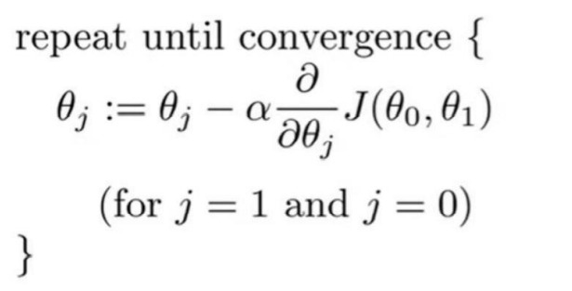

After we partially differentiate the cost function J(θ0 , θ1 ) for j=0 and 1, the

algorithm is:

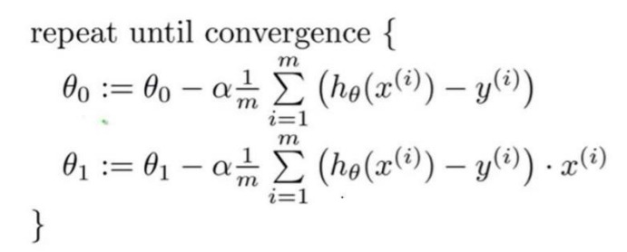

Feature scaling

If the predictors have very different scales, you must do feature scaling before running the gradient

descent algorithm. If you run the algorithm without feature scaling, it will take a very long time to reach

the global minimum.

1. No need to do feature scaling if there is only one predictor variable.

2. Do feature scaling if predictors have very different scales such as 1:100, 1:1000.

3. Do feature scaling only for predictors. No need to apply feature scaling for the response variable even

if it has a very different scale.

4. A common technique for feature scaling is mean normalization which involves subtracting the

average value for an input variable and divide that result by the standard deviation of that variable

1. **Methodology**

Predictive Analytics: is an applied field that uses a variety of quantitative methods that make

use of data to make predictions and it is an iterative process in which you will always

find yourself going back and forth between the below steps to build a better model which

captures a great amount of variability in your data.

The steps of the predictive analytics process are:

1. Problem understanding and definition

2. Data collection and preparation

3. Dataset understanding using Exploratory Data Analysis (EDA)

4. Model building

5. Model evaluation

6. Model implementation

1. **Plan of work**

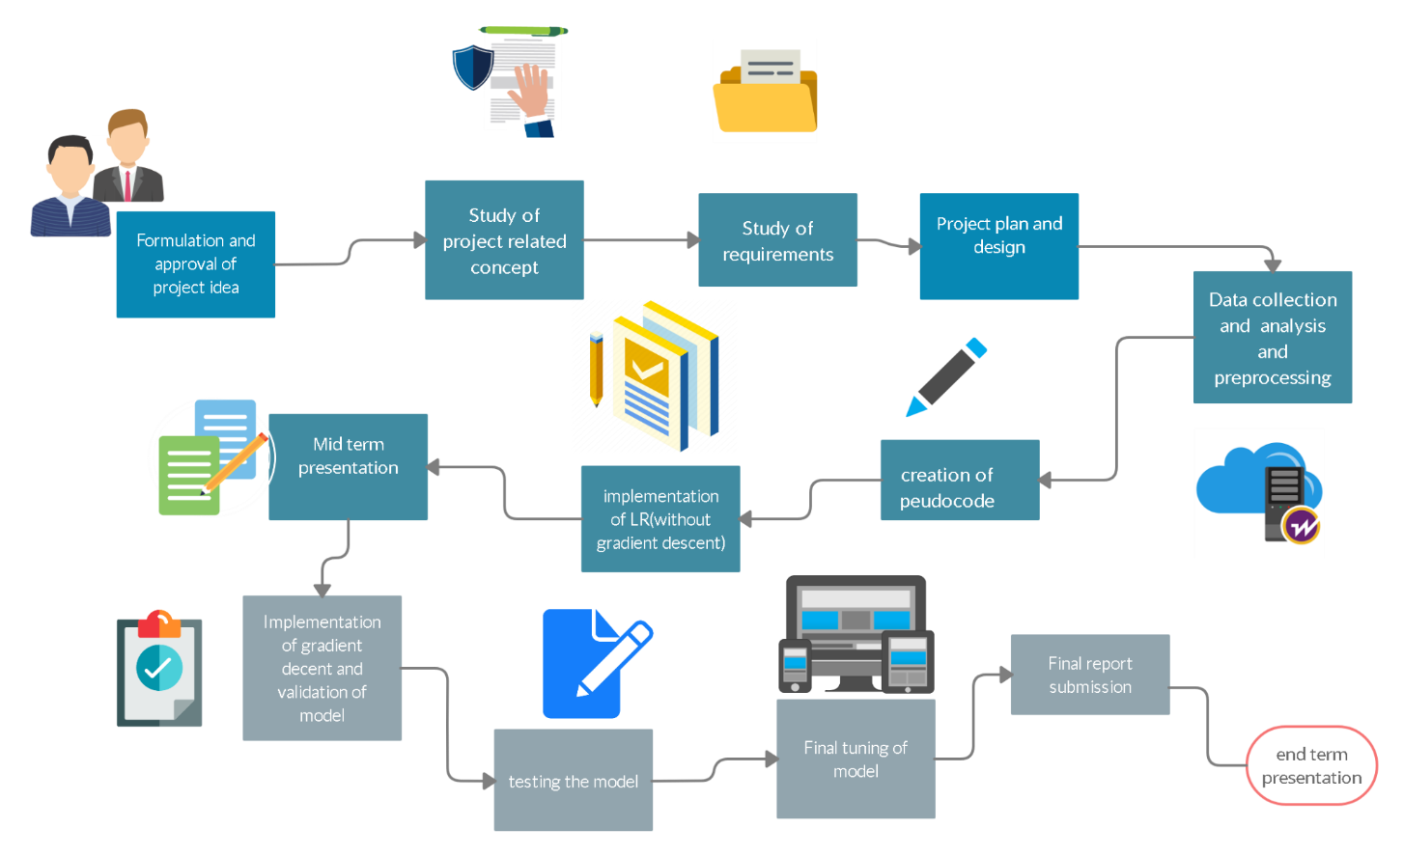

**References**

[1] Stochastic Gradient Descent using Linear Regression with Python, J V N Lakshmi, Research Scholar

Department of Computer Science and Application, SCSVMV University, Kanchipuram, India, 2016

[2] Linear Regression with Gradient Descent, Rukshan Pramoditha, 2020